Lesson 8: Where did the energy in our launcher system come from, and after the collisions where did it go to?

Previous Lesson | We carried out an investigation to determine how doubling the speed of an object vs. doubling its mass affects the amount of damage it does in a collision. We used a computer simulation to collect data on the relationship among the mass, speed, and kinetic energy of an object. We developed mathematical models of these relationships and used them to predict and explain how this could affect the amount of damage in a collision.
This Lesson  Investigation  1 day   | 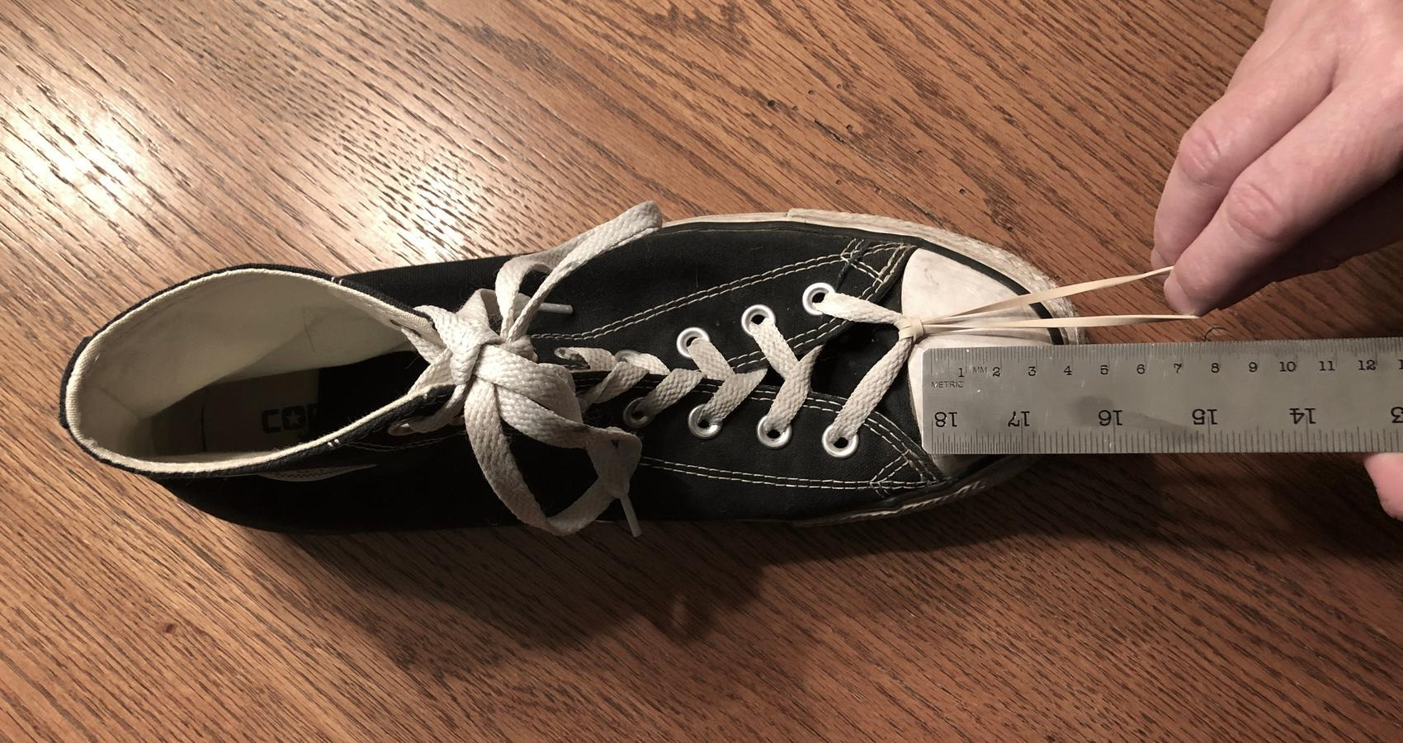 | We develop a model to show where energy is transferred between the spring, cart, and box and how contact forces cause this energy transfer. We use this to start brainstorming other places where contact forces may be causing energy transfer in the system.
Next Lesson | We will conduct investigations to gather evidence to explain what other forces affect the kinetic energy of an object before a collision. We will develop claims using our evidence and provide and receive feedback with peers to synthesize our ideas. We will revise our model to show additional places in the launcher system where energy is transferred and how contact forces cause this energy transfer.

BUILDING TOWARD NGSS  MS-PS2-1, MS-PS2-2, MS-PS3-1, MS-ETS1-2, MS-ETS1-3, MS-LS1-8   | What students will do  8.A Develop and use a model to identify other parts of the system the cart and box are making contact with or colliding into that could be producing contact forces on these subsystems, causing energy to be transferred to or from them as the box and cart travel down the track.  What students will figure out  - The more force you apply to an object the more that object speeds up.  - It takes more force to speed up a more-massive object the same amount as a lower-mass object.  - Potential energy can be stored in some systems when you change the shape or arrangement of parts in that system (e.g., a spring).  - Contact forces transfer energy between different objects or subsystems within the larger cart-launcher system.

Lesson 8 • Learning Plan Snapshot
Part | Duration |  | Summary | Slide | Materials
1 | 8 min |  | NAVIGATION  Share new questions related to where energy was transferred from and to in the spring-scale cart-launcher and box system. | A
2 | 5 min |  | INDIVIDUAL EXPLANATIONS  Construct explanations about where and how energy was transferred from and to in the spring-scale cart-launcher and box system. | B | Tracking energy transfers in our launcher system
3 | 20 min |  | DEVELOP A CONSENSUS MODEL OF ENERGY TRANSFERS IN THE SYSTEM  Develop a model in a Scientists Circle to show where energy was transferred from and to in the spring-scale cart launcher and how contact forces caused this energy transfer up to the point of the collision between the cart and the box. | C | Energy transfers and contact forces in the launcher, cart, track, and box system, colored pencils, Energy transfers and contact forces in the launcher, cart, track, and box system poster, colored markers, 13 prelabeled post-its (9 triangular with words, 2 square with red dots, and 2 rectangular with blue curved arrows).
4 | 7 min |  | INDIVIDUAL MODELS  Develop and use a model to identify other parts of the system the cart and box are making contact with or colliding into that could be producing contact forces on these subsystems. | D | Energy transfers and contact forces in the launcher, cart, track, and box system, Modeling other force interactions in the launcher, cart, box, and track system, colored pencils, Contact Force Interactions poster from Lesson 5 (optional)
5 | 5 min |  | NAVIGATION  Discuss other parts of the system that the box and cart are making contact with that could be producing contact forces. | E | 4 index cards, 1 rubber band, Investigating Surface Interactions, Investigating Interactions with the Air, Energy transfers and contact forces in the launcher, cart, track, and box system poster, 18 prelabeled post-its (14 triangular, 2 square, and 2 rectangular).

End of day 1

Lesson 8 • Materials List
 | per student | per group | per class
Lesson materials | - science notebook  - Tracking energy transfers in our launcher system  - Energy transfers and contact forces in the launcher, cart, track, and box system  - colored pencils  - Modeling other force interactions in the launcher, cart, box, and track system  - 4 index cards  - 1 rubber band  - Investigating Surface Interactions  - Investigating Interactions with the Air |  | - Energy transfers and contact forces in the launcher  - cart  - track  - and box system poster  - colored markers  - 13 prelabeled post-its (9 triangular with words  - 2 square with red dots  - and 2 rectangular with blue curved arrows).  - Contact Force Interactions poster from Lesson 5 (optional)  - 18 prelabeled post-its (14 triangular  - 2 square  - and 2 rectangular).

Materials preparation (20 minutes)

Review teacher guide, slides, and teacher references or keys (if applicable).

Make copies of handouts and ensure sufficient copies of student references, readings, and procedures are available.

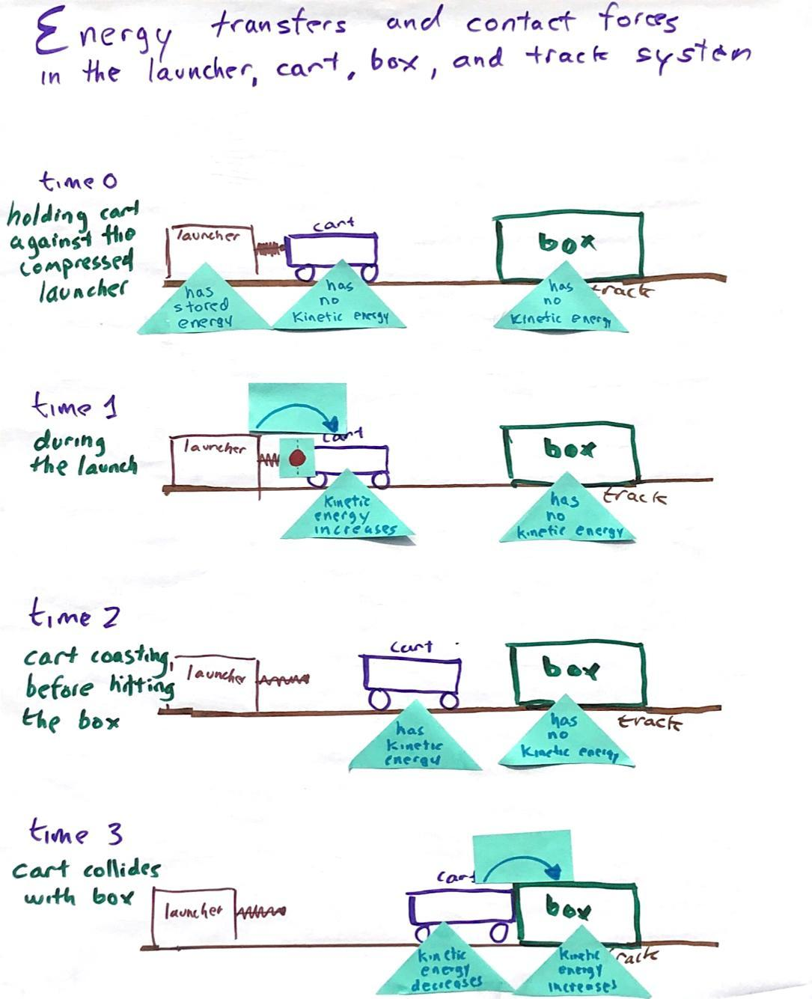
Make a copy of Investigating Surface Interactions and Investigating Interactions with the Air for each student as you may find that most students elect to do both rather than just one of the investigations as home learning.

Before class begins, make a poster titled “Energy transfers and contact forces in the launcher, cart, track, and box system” so that it mirrors the top portion of Energy transfers and contact forces in the launcher, cart, track, and box system and includes only time 0 through time 3.

Cut 9 sticky notes (3” x 3”) in half along the diagonal, keeping the sticky backed halves. Label the diagonal pieces as shown in the farthest photo to the right. Take 2 uncut sticky notes (3” x 3”) and label them with a curved blue arrow. Cut out 2 rectangles out of another sticky note that are approximately 1” x 1.5”. and draw a red circle on each. This will make 13 total sticky notes.

Position all of these sticky notes on the poster ahead of time to make sure you can lay them out in the positions shown. Remove these sticky notes and set them to the side to reuse between classes so that you can interactively place them on the poster with your next class.

Prepare sets of 4 index cards and a rubber band wrapped around them for each student to take home.

Lesson 8 • Where We Are Going and NOT Going

Where We Are Going

Students learn that contact forces are causing energy transfer through the launcher system, and they generalize this idea as contact forces can cause energy transfer in any system. Students will use this idea in the Lesson 9 assessment and will revisit it in future OpenSciEd units, including OpenSciEd Unit 8.2: How can a sound make something move? (Sound Unit).

They learn that potential energy can be stored in some systems when the shape or arrangement of parts in that system is changed (e.g., a spring). This is the first introduction to stored (potential) energy in the OpenSciEd unit sequence. Students will expand and deepen their understanding of this form of energy in OpenSciEd Unit 8.3: How can a magnet move another object without touching it? (Magnets Unit), where they figure out that the field between objects stores potential energy in the field and exerts distance forces on the objects that produced the field and also .

Students brainstorm additional sources of matter the box and cart are in contact with that may be producing contact forces on them to account for where the energy in the system is transferred to explain why those objects eventually stop moving. They are likely to generate two main sources of matter in the system: the track and the air. These two subsystems will be ones they investigate further in their home learning and in investigations in the next lesson. The at-home investigations and those in lesson 9 will help them identify interactions with the air (air resistance) and sliding surface friction as two important contact force interactions causing energy to transfer from the cart and box to their surroundings.

Where We Are NOT Going

Students will not identify other energy transfers to the surroundings such as those due to sound or infrared radiative cooling. The former is addressed in the next OpenSciEd unit of study in the 8th grade scope and sequence: OpenSciEd Unit 8.2: How can a sound make something move? (Sound Unit). The latter is beyond grade-band targets for the disciplinary core ideas.

The energy transfer and force interaction model that you develop for the launcher system in this lesson and revise in the next lesson will include contact forces acting in the horizontal direction only. The model will not include contact forces that are the result of gravity (e.g., normal forces). Considering forces in more than one dimension at a time is also an off-grade-band learning target (high school).

LEARNING PLAN for LESSON 8
1 · NAVIGATION | 8 min
MATERIALS: None
Share questions that were raised at the end of the last lesson. Say, At the end of the last class, we started considering energy transfer in the launcher, cart, track, and box system in order to better understand what is happening in that system. What new questions did thinking about energy transfer in the entire system raise for you? Display slide A. Discuss these questions as a class.  Say, In order to think about the energy transfer into and through an entire system, scientists and engineers often break bigger systems into subsystems to try to figure out what is going on. You’ve done this in many of the previous units in earlier grades. Let’s recall a few of those examples to think about how powerful this type of system thinking has been for us in the past. Ask students for examples based on the prior OpenSciEd unit experiences.  Say, These are great examples of where breaking the bigger systems into subsystems helped us figure out what was going on. Such system thinking is a powerful crosscutting concept that helped us make sense of more complex systems in the past. In addition to breaking up the system into smaller objects or smaller subsystems, it can also be useful to try to take what is happening in a given period of time and try to break it down into smaller chunks of time. In our launcher system, there was a lot happening between getting ready to launch the cart and seeing what the results were. So it may be useful to think about specific moments in time before, during, and after the cart is launched as well as before, during, and after the box is pushed. Throughout each period of time it may also be useful to think about the interactions occurring between different subsystems and objects within the larger system. | ✱ SUPPORTING STUDENTS IN DEVELOPING AND USING SYSTEMS AND SYSTEM MODELS  Prior to this lesson students have been thinking about different components of the cart subsystem with a lens of the matter moving and the resulting damage due to this movement. Now students are beginning to think about how energy is part of this system. They make connections to how objects within the larger cart system interact with each other and how different components of the system and subsystems are interrelated, causing objects to move and eventually stop.
  Suggested prompt | Sample student response
  What new questions did thinking about energy transfer into and through the entire system raise for you? | Do we put energy into the system?  How does the cart get energy anyways?  Does the tension of the spring have energy?  Does pulling the spring back different amounts give it different amounts of energy?  How does energy from you get to the cart?  Does the energy go into the ground?  Does energy go into the cracker or the brick?  Do the opposing forces between objects cancel out some of the energy in the system?  Is all the energy that goes into the cart going into the box?  If energy goes into the ground, what happens to it when it goes there?  Does the energy go other places outside of the system and we just can’t detect it?
  Suggested prompt | Sample student response
  What were the subsystems you used to try to explain why different people saw different things on either side of a one-way mirror in your work in OpenSciEd Unit 6.1: Why do we sometimes see different things when looking at the same object? (One-way Mirror Unit)? | Two different rooms, the surface of the mirror, different people at different locations.
  What subsystems did you identify for the cup in your work in OpenSciEd Unit 6.2: How can containers keep stuff from warming up or cooling down? (Cup Design Unit) to try to think about how energy was transferring through the larger system? | The liquid, the walls and lid, the air between separate walls, and the air outside the cup.
  What subsystems did you focus on to think about energy transfer into the formation of a hailstorm in OpenSciEd Unit 6.3: Why does a lot of hail, rain, or snow fall at some times and not others? (Storms Unit)? | The light’s interaction with the ground and/or surface.  The interaction between the Earth’s surface and the air above the surface.  Parcels of air rising and falling.
  What subsystems did you break the body into to think about what was causing M’Kenna to feel the way she did in OpenSciEd Unit 7.3: How do things inside our bodies work together to make us feel the way we do? (Inside Our Bodies Unit). | The digestive system, the circulatory system, and the respiratory system.  Cells within specific tissues or organs.

2 · INDIVIDUAL EXPLANATIONS | 5 min
MATERIALS: science notebook, Tracking energy transfers in our launcher system
Develop initial explanations for where energy transfers may be occuring. Display slide B. Distribute Tracking energy transfers in our launcher system. Have students add this to their science notebooks. Give students about four minutes to answer the questions on the handout.

3 · DEVELOP A CONSENSUS MODEL OF ENERGY TRANSFERS IN THE SYSTEM | 20 min
MATERIALS: science notebook, Energy transfers and contact forces in the launcher, cart, track, and box system, colored pencils, Energy transfers and contact forces in the launcher, cart, track, and box system poster, colored markers, 13 prelabeled post-its (9 triangular with words, 2 square with red dots, and 2 rectangular with blue curved arrows).
Discuss where energy transfer is occuring in the system. Display slide C. Convene students in a Scientists Circle to discuss some of their ideas.

Suggested prompt | Sample student response
What did your group do to the launcher so that it could eventually transfer energy to the cart? | We used our hands to pull it back.  We pushed into the plunger or against the cart to push it backward.  We compressed the spring in the launcher.
What did your group do differently to the launcher so that it could transfer more energy to the cart for condition B or C compared to condition A? | We pulled it back further.  We pushed it back harder or further.
What part of the launcher subsystem directly transferred energy to the cart to get it moving? | The tip of the plunger.
How did that part of the launcher subsystem  transfer energy to the cart? | It pushed on the cart as it returned to its original position.  Contact forces between the plunger and the cart.
What did the launcher do after you released it that enabled it to transfer more energy to the cart in condition B or C than in condition A? | It pushed with a stronger force at first when it was released from a more-compressed position.  It pushed the cart over a longer distance (or time).

Switch to a diagrammatic representation of the system. Say, Let’s capture all of these ideas in a system diagram of the spring launcher, cart, track, and box system. We can use this model to show how energy was transferred through the spring-scale-launched cart system that collided with the box.

Distribute Energy transfers and contact forces in the launcher, cart, track, and box system. Ask students to compare the objects or subsystems represented for each of the times shown in the model and describe what is different and what is the same for each time shown.

Suggested prompt | Sample student response
What objects or subsystems are represented in this system model? | The launcher, the cart, the box, and the track,.
What is different about these objects in some of the times? | The launcher spring is compressed in time 0, but not the other times.  The cart is moving in times 1 through 4, but not in time 0 or time 5.  The position of the box is the same in times 0 through 2, but changes in times 3 through 5.
What does time 0 show? | The cart before it is launched.
What does time 2 show? | The cart traveling down the track after it is launched.
What does time 5 show? | The box and cart after they came to a stop.

Post the premade poster that you created representing the Energy transfer and contact forces in the launcher, cart, box, and track system model. You will use the 13 prelabeled post-its (14 triangular, 2 square, and 2 rectangular) to annotate this model so that you can remove these annotations before the next class and repeat this interaction-system-modeling exercise and discussion with your next class.

Direct students’ attention to time 2 and time 0. Ask students which objects or subsystems have kinetic energy and which do not at time 0 and time 2. Students should say only the cart in time 2 has kinetic energy and nothing else does.  Add the triangular sticky note “has kinetic energy” to the cart at time 2.  Add the triangular sticky note labeled “has no kinetic energy” to the cart at time 0 and the box at both time 0 and time 2.  Have students add the same annotations to their copy of Energy transfers and contact forces in the launcher, cart, track, and box system. | 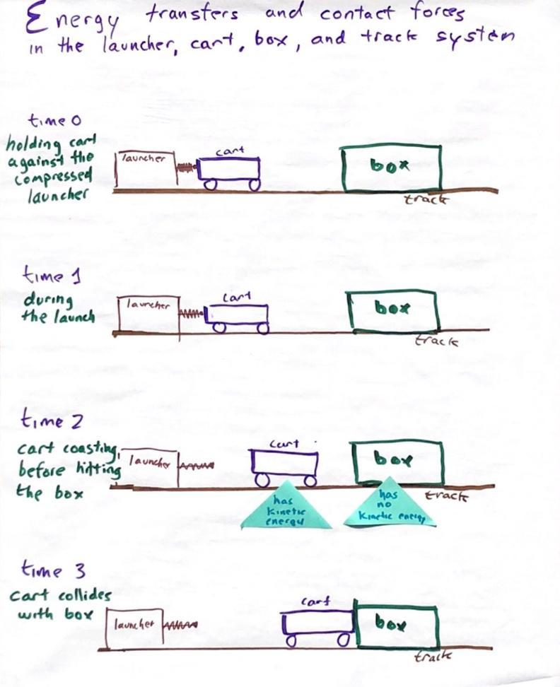

Introduce the idea that energy can be stored in systems in some cases when the shape or position of parts or objects change. Say, When we compressed the spring scale and held the cart motionless against it, it wasn’t moving, so therefore it has no kinetic energy. But we know energy is transferred from the launcher to the cart when we release it. The compressed spring scale is an example of a subsystem that can store energy that can be transferred out of it later. Compressing the spring by pushing on it allowed us to transfer energy into that part of the subsystem. Holding the spring in place allowed it to remain in a particular shape or position where it could continue to store that energy. And letting go of it allowed the launcher to spring back to its original shape or position. As it returned to its original shape or position, the energy that was stored in that part of the subsystem was transferred back out of it. Scientists also refer to the stored energy in a system that is the result of a change in the position of objects in the system as potential energy.

ADDITIONAL GUIDANCE | Referring to this energy stored in the configuration of the parts of a system as “potential energy” has some trade-offs in terms of simplicity of understanding versus accuracy of representation. But it will be beneficial for future work--thinking about energy stored in magnetic fields due to the position of the magnets relative to each other--in OpenSciEd unit OpenSciEd Unit 8.3: How can a magnet move another object without touching it? (Magnets Unit). The spring launcher will be an analogous physical structure that students use to visualize what is happening when a magnetic field is deformed. Springs are a more-concrete way to visualize how energy can be stored in a system before introducing the idea that energy is stored in the field of a system due to distance forces. So more exactly, it's not the spring that is storing the potential energy, it is the spring system. In that system it ultimately is the electric field between the atoms that make up the spring launcher and the matter that it is in contact with that holds the spring in a compressed form. In that form, the position and orientation of the atoms that make up the matter shift and the field between them stores the energy in the system. This is beyond grade-level understanding and would not be beneficial to introduce here.

Review what is causing the energy to get transferred into and out of the system.

Suggested prompt | Sample student response
What did we do to the push-pull spring scale system that provided it energy that it could later transfer to the cart? | We compressed it.
What happens to the amount of stored or potential energy in the spring-launcher system as we compress the spring more? | It increases.
How did letting go of the cart cause the potential energy in one part of the system to get transferred out of it into the cart as kinetic energy? | The kinetic energy from the push of the spring scale as it uncompressed transferred from the spring to the cart.  From contact forces between the spring scale and the cart.

Add the triangular sticky note labeled “has stored energy” to the launcher at time 0.  Make a key on a piece of letter sized paper taped to the side of the poster. Add a curved blue arrow to the key and label it “energy is being transferred”.  Add a rectangular sticky note with a curved, blue arrow going from the launcher to the cart at time 1.  Add a red dot to the key and label it “due to contact forces here”. Then ask students where the contact forces are between the launcher and the cart at time 1 that are causing this energy transfer. Students should say where the plunger is touching the back of the cart. Add a small square sticky note with a red dot on it to that location at time 1.  Add the triangular sticky note labeled “kinetic energy increases” to the cart at time 1. | 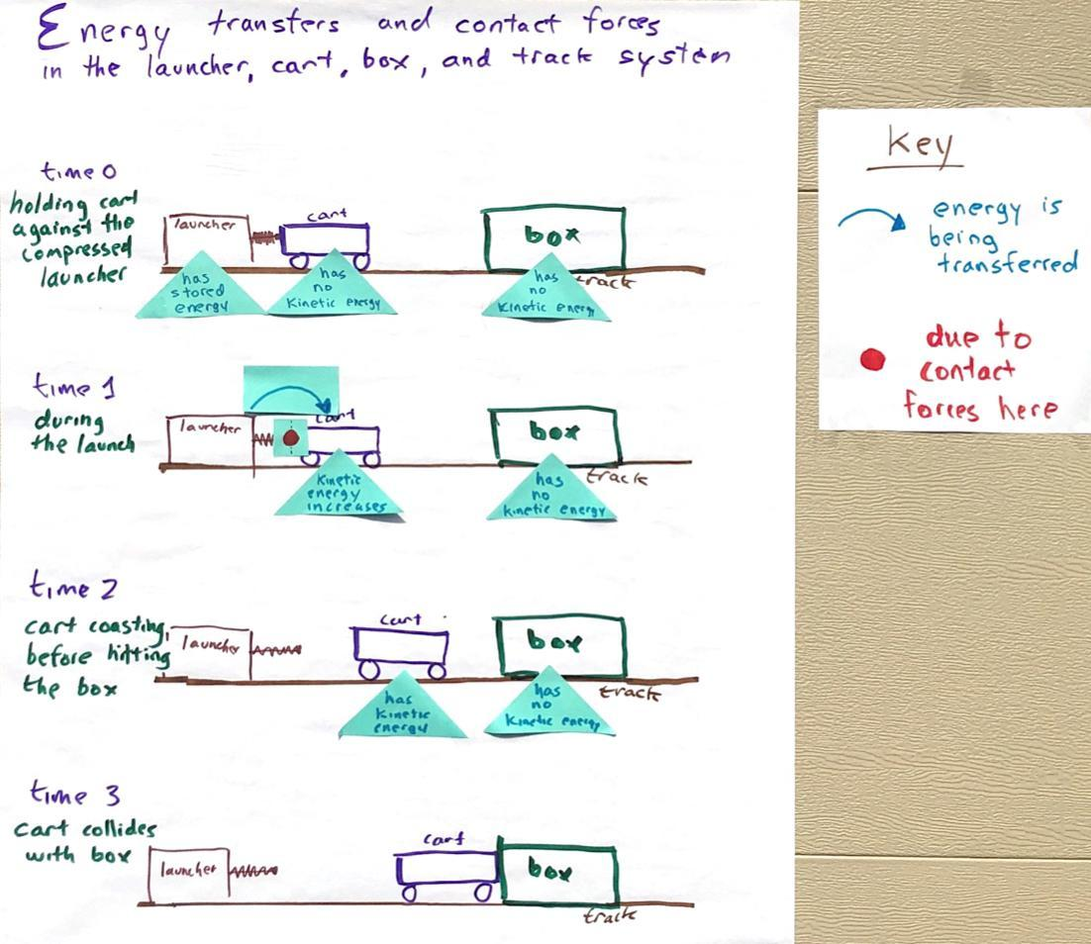
Have students add the same annotations to their copy of Energy transfers and contact forces in the launcher, cart, track, and box system.

Point out that the red dot shows where the contact forces are occurring in the system but doesn’t show how many forces there are at that point of contact nor their relative strength like we showed earlier when we made a free body diagram of each object or subsystem in a collision.

For time 1, review how many forces there are at this point of contact and their relative strength.

Suggested prompt | Sample student response
If we did make individual free body diagrams to represent the contact forces at work in the system, would we show that there is a single force acting on the launcher, a single force acting on the cart, or a force acting on both? | A force acting on both.
How would the relative strength of the forces on both compare? Would they be different strengths or would they be the same strength? | They would be the same strength.
How would the direction of the forces on both compare? | They would be in opposite directions.

Prompt students to consider time 3. Ask students what happens to the stationary box when the cart collides with it. Students should say it starts moving.  Ask students where the energy was transferred from that causes the kinetic energy of the box to increase. Students will say from the cart.  Add the triangular sticky note labeled “kinetic energy increases” to the box at time 3.  Add a rectangular sticky note with a curved, blue arrow going from the cart to the box at time 3.  Then ask students what must be happening to the kinetic energy of the cart if energy is being transferred from it to the box during the collision. Students will say it must be decreasing.  Add the triangular sticky note labeled “kinetic energy decreases” on it to the cart at time 3.  Ask students to identify where the contact forces are between the cart and box. Add a small square sticky note with a red dot on it to that location. | 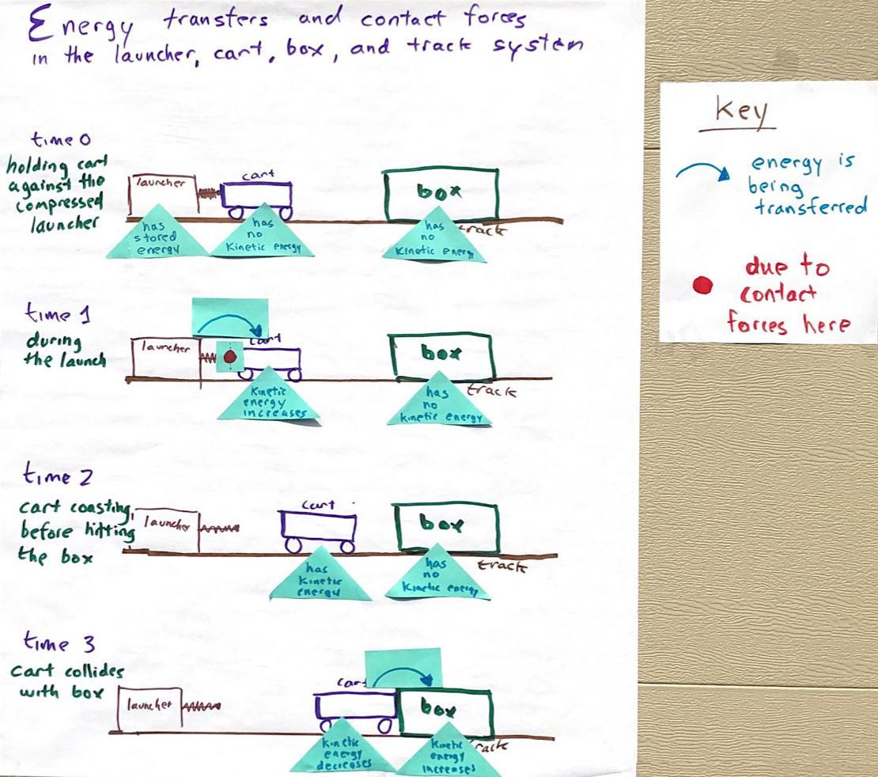
Emphasize that, again, we have identified a location in the system where energy transfer is occurring due to contact forces between two objects or subsystems. Have students add the same annotations to their copy of Energy transfers and contact forces in the launcher, cart, track, and box system.

Direct students to time 5, suggesting that you want to identify a few things here first before returning to time 4.

Ask students what we can say about the kinetic energy of all the objects or subsystems at time 5 if everything has stopped moving. Students will say that they have no kinetic energy. Have students add these annotations to the cart and the box in time 5 on their copy of Energy transfers and contact forces in the launcher, cart, track, and box system.

Direct students to time 4, asking what is happening with the speed of the cart and the box as they slide along the track to a stop. Students will say they are slowing down. Have students label both the cart and the box with “KE decreases”.

Problematize something missing from the model. Say, Wait, where did the energy in the system go between time 3 and time 5. Some of the objects had kinetic energy at time 3, but by time 5 there is no kinetic energy in the system. Energy can’t just disappear. It can be transferred from one object, subsystem, or system to another. We saw that happen due to contact forces between certain objects and subsystems at time 1 and time 3. But here at time 4 it's not obvious where that energy went, nor is it obvious what contact forces would have caused this energy transfer. So I don’t think we are done with this model yet. But let’s have you think on your own a bit more about what else might be going on in this system from both an energy transfer perspective and a contact forces perspective.

4 · INDIVIDUAL MODELS | 7 min
MATERIALS: science notebook, Energy transfers and contact forces in the launcher, cart, track, and box system, Modeling other force interactions in the launcher, cart, box, and track system, colored pencils, Contact Force Interactions poster from Lesson 5 (optional)
Say, We put red circles in our systems model to show where contact forces are occurring. In the past, when we wanted to show more about what the forces are at those red circles, we drew free body diagrams. We haven’t done that for any of our points in time in the model so far. But let’s not forget that free body diagrams are a helpful tool for visualizing the forces acting on objects in the system. Let’s get ready to develop and revise some free body diagrams for both the box and the cart at time 4. Before we do, let’s look back at how we drew the free body diagrams we made in the past.

Review what was included in past free body diagrams the class made in Lesson 5. Cue students to look back at an example of the ones they made in their notebooks and/or on the poster you made as class from Lesson 5.

Suggested prompt | Sample student response
Even though there are two objects interacting when there are contact forces between them, how many objects do we show in a single free body diagram? | One.
What do the arrows in the diagram represent? | A force acting on the object.
What does the direction of the arrow represent? | The direction of the force on the object.
What are we trying to show when we put the tip of the force arrow on one surface of the object instead of another? | Which surface that force is acting on.
Up to now you have only shown a single force acting on an object. Next you will be asked to consider if there are other forces acting on those objects as well. If you decide there are, then how would you show more than one force acting on an object? | Use more than one arrow.

Show slide D. Distribute Modeling other force interactions in the launcher, cart, box, and track system. Say, Use the annotations we made to Energy transfers and contact forces in the launcher, cart, track, and box system and consider what else might be going on at time 4, starting first by thinking about forces in the system using free body diagrams. Emphasize that you want to collect this as a formative assessment to see how students are thinking about other forces acting on the box and the cart at this point in time as well as how and where energy transfer may be occuring.

Collect the completed responses before moving to the end of the lesson.

ASSESSMENT OPPORTUNITY | Building towards: 8.A Develop and use a model to identify other parts of the system the cart and box are making contact with or colliding into that could be producing contact forces on these subsystems, causing energy to be transferred to or from them as the box and cart travel down the track.  What to look for: See Key for modeling force interactions in the launcher, cart, box, and track system for guidance on what to look for.  What to do: Treat this as an informal assessment of prior knowledge related to how forces from friction and air resistance act on moving objects. Do not correct preconceptions at this point. Make a copy of student responses on Modeling other force interactions in the launcher, cart, box, and track system so you can return the original to students to revise at the end of the next lesson (Lesson 9) as a home-learning assignment. This will provide you a reference to compare student thinking before Lesson 9 to what they are thinking by the end of Lesson 9.

5 · NAVIGATION | 5 min
MATERIALS: 4 index cards, 1 rubber band, Investigating Surface Interactions, Investigating Interactions with the Air, Energy transfers and contact forces in the launcher, cart, track, and box system poster, 18 prelabeled post-its (14 triangular, 2 square, and 2 rectangular).
Discuss other sources of contact forces as a whole class.  Introduce the ideas of friction and air resistance. Students may or may not have used the words friction and air resistance at this point in the unit. If students have used these terms, acknowledge the terms here. If they have not, start to link the words with the concepts. Use one of the two prompts below that best fits your classroom case.  - Option 1: Introduce what these two sources of contact forces are commonly called. Say, The contact forces between a moving object and something it is sliding against are commonly called friction, and the contact forces between a moving object and the air particles it collides with are commonly called air resistance.  - Option 2: Acknowledge the use of the words friction and air resistance. Say, I hear you all saying the word friction to describe the forces between an object and something it is sliding against. I also hear you using the word air resistance to describe contact forces between a moving object and the air particles that it collides with. These are interesting words. Let’s see if we can really develop our ideas of what these terms mean as we explore these contact forces.  Ask students for a few examples in other systems or phenomena where they think that contact forces due to friction affect the kinetic energy of an object as it moves. Do the same for air resistance. Accept all responses.  Suggest that since these forces may be part of many other systems where there are objects moving, what causes these forces and how they affect the motion of objects before, during, and after a collision appears to be another part of the system model we will need to figure out more about in order to answer our unit driving question, “Why do things sometimes get damaged when they hit each other?”.  Introduce home learning. Show slide E. Say, Tonight you have an option to do one of two investigations. One of these involves folding and dropping index cards to see which shapes you can get to travel more quickly and more slowly through the air. The other involves pulling on a shoe with a rubber band to see how much force it takes to get it to start moving when it is on different surfaces. I will give you supplies that can be used for either investigation, which are four index cards and a rubber band. You pick which investigation you want to do. If you do the latter investigation you will also need a shoe and a ruler.  Distribute four index cards with a rubber band wrapped around them to each student.  Distribute Investigating Surface Interactions to students who select the first investigation to carry out. Distribute Investigating Interactions with the Air to students who select the second investigation to carry out.  Tell students that they will share their results with other students at the start of the next class.  Remove the 16 prelabeled post-its (14 triangular, 2 square, and 2 rectangular) from the poster and set them to the side before the next class so they can be reused for placement on the poster. | ✱ ATTENDING TO EQUITY  Universal Design for Learning: You may find that some students want to engage with these investigations and ask to do both at home. If so, encourage them to do so, but don’t require this of all students. Providing an option of which investigation to do rather than requiring both gives students a choice to pursue a line of inquiry that is more relevant to them. Some may consider both intriguing, and for those students, giving them the choice to pursue both is also an important option to engage students as well.
  Suggested prompt | Sample student response
  What other objects or subsystems is the box either making contact with or colliding with at time 4 besides the cart? | The track.
  The track is something that is easy to see the box making contact with. But the cart also makes contact with it or the surface under it. Are there any other sources of matter that the box and cart are colliding with or making contact with besides the track and surface under it? | The air.
  If we were to zoom in and try to visualize what is happening to the particles that make up the air, what do you picture happening to those particles when the box and cart run into them? | They would get pushed out of the way.  They would hit the box or cart and bounce off.
  What part of the box would be hitting the most air particles as it is sliding down the track? | The front.
  What part of the box is making contact with the track as it is sliding down it? | The bottom.
  ADDITIONAL GUIDANCE | Don’t add the terms friction or air resistance to the Word Wall yet. You will do that at the start of the next lesson after all students have gathered some first-hand experiences with related phenomena in the home learning.

